Step 1 : create an entity class in the model package
import lombok.AllArgsConstructor;
import lombok.Data;
import lombok.NoArgsConstructor;

@NoArgsConstructor
@AllArgsConstructor
@Data
@Entity
public class Product {

@Id
@GeneratedValue(strategy = GenerationType.IDENTITY)
private int pno;
private String pname;
private double price;
}

Step 4 : save and restart the application, the newly created table by the name of the entity class will reflect in the database.

Step 5 : for the model class make a
Class Controller
Class Service
Interface Repository
NOTE:
make them in their respective packages
Prefix the name of the model class before them
e.g
ProductController
ProductService
ProductRepository
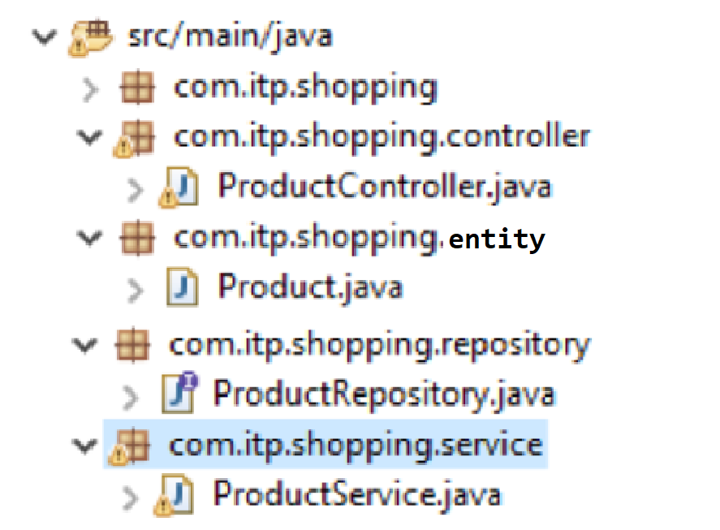

package com.itp.shopping.controller;

import org.springframework.web.bind.annotation.RestController;

@RestController
public class ProductController {

}

package com.itp.shopping.service;

import org.springframework.stereotype.Service;

@Service
public class ProductService {

}

package com.itp.shopping.repository;

import org.springframework.data.jpa.repository.JpaRepository;
import org.springframework.stereotype.Repository;

import com.excelr.firstapp.model.Student;

@Repository
public interface ProductRepository extends JpaRepository<Product, Integer>
{

}

